LBWF, the Local Authority Business Growth Initiative programmes One and Two, and the Waltham Forest Business Board, E11 Bid Co., and
North London Ltd.

Summary

- Between 2007 and 2011, LBWF received Local Authority Business Growth Initiative (LABGI) monies worth £2,569,014.

- LBWF used some of this money for its own projects, and also allocated £540,000 to the Waltham Forest Business Board’s operating arm, Waltham Forest Business CIC (WFB), contracting the latter to stimulate two local BID Companies.

- Exactly what was achieved by the expenditure of the LABGI monies in terms of outputs and outcomes is difficult to gauge, and this is particularly true of the sums passed to the WFB, as when questioned under the Freedom of Information Act (FIA), LBWF is able to produce only a small fraction of the monitoring data that was contractually required.

- What is abundantly clear, however, is that one of the beneficiaries, the E11 BID Co., was run chaotically and to some extent recklessly; and that the sums it received from WFB – c. £180,000 - currently cannot be accounted for.

- Questions also arise about the monies that were paid out for the LABGI programme's administration and running expenses, since these seem to be above the level that might be reasonably expected; and also a payment of £50,000 that WFB made to a third party, North London Ltd., which again has an uncertain fate.

- Research on these issues has thrown up two further worrying dimensions.

- One concern centers on North London Ltd., since beyond LABGI, it is established that this company received large amounts of additional public money, at least £1,108,000 (including £455,279 from LBWF alone); spent it in ways that are not always easy to trace; and recently was forced into administration, while provoking concerns in City Hall.

- In addition, it is a fact that two of the key figures on the WFB board were also directors of delivery organisations which received WFB funding, specifically the E11 BID Co. and NLL, and this raises reasonable questions about their roles and how they mitigated potential conflicts of interest.

- In conclusion, over recent years, LBWF has been involved in a series of well-publicised scandals about its use of public money, involving, amongst others things, the Neighbourhood Renewal Fund, the collapsed local charity O-Regen, and its own Worknet programme.

- What is documented in the following pages suggests that few lessons have been learnt, and underlines the need for an independent inquiry into how the local authority operates.

LBWF, the Local Authority Business Growth Initiative programmes One and Two, and the Waltham Forest Business Board, E11 Bid Co., and
North London Ltd.

Introduction

1. Between 2007 and 2011, LBWF received Local Authority Business Growth Initiative (LABGI) monies worth £2,569,014, £708,201 under programme One in 2007-09, and £1,860,813 under programme Two in 2009-11.

2. According to the Department of Communities and Local Government, the LABGI initiative aimed to give ‘local authorities a financial incentive to encourage local business growth by rewarding qualifying business growth with a non-ringfenced grant’.

3. LBWF appears to have spent the bulk of its LABGI allocation on its own schemes, for example, the development of ‘Area Action Plans’ (cost £219,617) and a ‘Borough Legacy Plan’ (cost £143,970); ‘Climate change business outreach’ (projected cost ‘£105k’); ‘Construction skills centre contingency’ (projected cost ‘£418k’); and ‘Olympic projects’ (projected cost ‘£210k’).

4. But in addition, LBWF allocated at least £540,000 of the LABGI monies to the Waltham Forest Business Board (WFBB), £140,000 in 2007-09, and £400,000 in 2009-11, the object being to support the latter’s operation ‘as a governing body of many local businesses’, and specifically to allow it to help develop the borough’s two recently created Business Improvement District (BID) companies, the Argall BID Co., and the E11 BID Co. (each incorporated in 2007).

5. Turning to outputs and outcomes, what LBWF achieved through its own schemes remains opaque. The construction skills centre was built, and though the majority of the money involved came from the Learning and Skills Council, LBWF certainly contributed to its cost. Some of the other spending heads seem very vague, perhaps deliberately so. It may be significant that LBWF has never published a record of what its LABGI funds purchased, and recently ignored a specific request under the Freedom of Information Act (FIA) to identify ‘which organisations and/or persons received disbursements from this sum’.

6. As to the £540,000 given to the WFBB, what is known so far is hardly reassuring, as will be explained in the following paragraphs, which first broadly follow the chronology, and then turn to some recent revelations about the overall context.

The WFBB

7. The WFBB began operating in late 2005, and was described by LBWF as ‘the strategic partnership body between the local Council, regional government, central government and the business community in Waltham Forest.’

8. In the LABGI period and beyond, the WFBB chair was Michael Polledri, a prominent local property developer and philanthropist, based at Heron House, Hale Wharf, London, N.17. However, few other facts about the organisation are known, as it does not appear to have published a membership list, a constitution, or details of its finances.

9. In 2008, the WFBB set up a community interest company, Waltham Forest Business CIC (hereafter WFB), and subsequently used this as its operating arm. WFB was guided by a small group of directors, which included Mr. Polledri throughout, together with the E11 BID Co. chair Fawaad Sheikh (to March 2012), and the LBWF portfolio holder for ‘investment and enterprise’ Cllr. Terence Wheeler (to August 2011).

WFB and LABGI One spending

10. As regards WFB and LABGI One monies, LBWF records show that the entire sum was paid to the two BID companies, £15,000 in 2007-08, and £125,000 in 2008-09, though what this money purchased remains unrecorded.

WFB and LABGI Two spending (i) intentions

11. As regards the WFB and LABGI Two monies, the picture seems at first sight a lot clearer. On 24 December 2009, Mr. Polledri and Mr. Sheikh of WFB signed a contract with LBWF to ‘manage’ and ‘administer’ the funding , on the basis of the following detailed allocation, which was noted to be fixed and mandatory:

Activity | Funding
Dedicated Waltham Forest  Business Growth Officer  (‘Dedicated resource will ensure  WFBB and its forums are supported’) | £38,000
Business Champion (‘who will manage day-to-day operations of the board’) | £12,000
On-going secretariat and advice  (‘Salary costs to support business  forums, board and BID companies’) | £46,700
Business directory | £5,000
Communications (‘Website, Annual  Report and public affairs’) | £10,000
Board operating Budget | £18,000
‘Support BID Companies in their  projects within the community’ | £220,000
‘Part funding for E11 One Stop  business support centre’ | £50,000
Total | £399,700

12. Subsequently, according to a letter written by then Deputy Chief Executive Shifa Mustafa in January 2014, LBWF paid WFB £400,000 in six installments, starting in February 2010, and ending in March 2011.

13. However, tracing what happened when WFB moved to the operational phase of this contract reveals four sets of significant issues, concerning monitoring, the E11 BID Co., North London Ltd., and monies allotted to project support.

WFB and LABGI Two spending (ii) monitoring

14. The contract of 24 December 2009 required that WFB submit many different types of specific monitoring information, in particular formats, and at a series of pre-determined times. Moreover, the satisfaction of such requirements was clearly stated as mandatory, with non-compliance at any time constituting a breach.

15. Yet when questioned under the FIA, LBWF has struggled to produce this monitoring information, as the following examples demonstrate:

(a) at Annexure G, the contract required that WFB submit a De Minimis Aid Disclosure Form, to ensure that there was compliance with EU regulations.

LBWF states it ‘does not hold the information in recorded form’.

(b) at Schedule 3, paragraph 2.3, the contract required that WFB ‘provide periodic returns containing information in relation to expenditure, Outputs, Milestones and risks in a format which complies with the requirements of Annexure D’.

LBWF has supplied some quarterly monitoring forms, but these are not in the form specified by Annexure D, indeed covering only a few of the required headings; and are also incomplete, missing those for two of the six quarters, July 2010 to September 2010 and January 2011 to March 2011.

(c) at Schedule 3, paragraph 3, the contract required that WFB submit ‘final reports in respect of all relevant Outputs relating to the Project’, and specified six particular headings (‘Job creation’, ‘Business support’, etc.).

LBWF states it ‘does not hold the information requested’.

(d) At Schedule 3, paragraph 2.4, the contract required WFB to supply annual statements of grant expenditure, ‘audited by your external auditor’, with special forms for both purposes provided at Annexure F.

LBWF has supplied two such forms, somewhat confusingly dated 10 June 2010 and 22 October 2010, which relate to £145,676 and £105,021 respectively, meaning that 37 per cent of the grant, some £149,303, is entirely unaccounted for. Moreover, in both cases the required forms signed off by an external auditor are missing.

16. Other evidence, too, confirms the fact that contract monitoring seems to have been at best patchy, at worst non-existent. For example, asked in 2013 the general question ‘In relation to the substantial monies that LBWF has paid over on a regular basis to the Waltham Forest Business CIC since 2009-10, please will you forward a list of the outputs that were produced?’, LBWF stated: ‘the Council does not hold the information requested’.

WFB and LABGI Two spending (iii) the E11 BID Co.

17. As part of the LABGI Two contract allocation, WFB paid the E11 BID Co. two sums worth £110,000, satisfying a pair of invoices for £55,000 dated 12 June and 20 September 2010 (see Appendices One and Two, below).

18. As is apparent, neither of these invoices is supported by any information as to what they were to pay for, nor do they have attached evidence of spend (e.g. receipts from third parties) – something markedly different from equivalent invoices submitted by the Argall BID.

19. LBWF’s quarterly monitoring form for 1 April 2010 to 30 June 2010 suggests that the £110,000 was used to purchase CCTV cameras, and was justified by a ‘Decision making audit trail’.

20. Questioned under the FIA, LBWF repeatedly refused to release this ‘Decision making audit trail’, but on appeal was then persuaded to do so by the Information Commissioner.

21. Significantly, when the documents released are closely examined, they turn out to relate, not to a contract for CCTV cameras, but to a contract for maintaining a CCTV network, worth only £18,000.

22. In addition, there are legitimate question about the timing of these two payments. In the 12 months to June 2010, the E11 BID Co. publicly admitted an operating loss of £80,012, considerably more than the total annual levy it received from traders.

23. Moreover, evidence had emerged that the E11 BID Co. was being chaotically run. Thus, at an E11 Bid Co. Board meeting of 16 September 2010, attended by, amongst others, Munawar Hussain (‘LBWF advisor to the Board’), Cllr Afzal Akram (‘Cabinet Member for LB Waltham Forest corporate’), and Mr. Polledri (‘Waltham Forest Business Board Chair’), there was extensive discussion of auditor Barnes Roffe’s recent annual management letter, which advised the need for clarification about, amongst other things, a host of elementary fundamentals, such as whether the E11 BID Co was:

- maintaining proper books of account;
- ensuring its cheques were being signed by two people in line with normal practice to avoid fraud;
- respecting appropriate restrictions on cash withdrawals;
- operating a proper PAYE system;
- clear about its VAT and corporation tax status; and
- certain that large cash withdrawals had been correctly authorised.

24. Indeed, during this period the situation had deteriorated to the extent that one ex-E11 BID Co. director was regularly contacting senior figures such as E11 BID Co. director Cllr. Clyde Loakes and Mr. Polledri with detailed complaints about the company’s problems, on at least one occasion also copying in the Leader of the Council, Chris Robbins.

25. What brings these developments into particularly sharp focus is the fact that the LBWF-WFB contract throughout stressed the importance of propriety, and for example required at paragraph 34.2 ‘If there are grounds for suspecting financial irregularity in any transaction…those grounds shall be notified to us immediately in writing’, and added ‘For this purpose “financial irregularity” includes, but is not limited to, fraud or other impropriety, mismanagement and the use of funding for purposes other than provided’.

WFB and LABGI Two spending (iv) North London Ltd.

26. The LBWF-WFB contract allocation, to repeat, included the sum of £50,000 to be paid for ‘Part funding for E11 One Stop business support centre’.

27. In March 2011, right at the end of the LABGI contract, a private company called North London Ltd. (NLL) presented WFB with an invoice dated 14 March 2011 for £50,000 (see Appendix Three, below).

28. According to LBWF, this invoice was paid to NLL ‘for support of the E11 One Stop Shop Business Support Centre’.

29. However, LBWF cannot say what this support consisted of, nor when it began and ended. And neither, of course, is the invoice of much help, with the ‘Description’ box reading only: ‘To provide project support as instructed by Waltham Forest Council’.

30. Mr. Polledri had become a director of NLL in 2005, and the company was based at Heron House, Hale Wharf (as WFB).

31. The One Stop Shop was not controlled by the E11 BID Co., but by a related company, The Leytonstone Business Forum CIC.

32. The directors of the Leytonstone Business Forum CIC were Mr. Sheikh (as reported, also a board member of both the E11 BID Co. and WFB), and two others, one of whom subsequently denied knowing anything about the company’s operation.

33. The Leytonstone Business Forum CIC had a substantial income of its own (much stemming from allegedly servicing the E11 BID Co.) and so it is far from clear why it needed extra ‘support’.

34. And, most significantly, the Leytonstone Business Forum CIC, was anyway first gazetted on 1 February 2011 and then dissolved on 17 May 2011 – making any ‘support’ payment even more questionable.

35. Finally, it should be emphasised that NLL was not cited in either the LBWF Cabinet paper originating LABGI Two, or the LBWF-WFB contract, and so must have been especially commissioned, raising questions about who organised this and whether there were any potential conflicts of interest involved.

WFB and LABGI Two spending (v) project support

36. As the table at paragraph 11 (above) indicates, LABGI Two included generous provision for project support. Indeed, £127,700, a third of the total, was earmarked for this end.

37. Such a sum seems surprising in particular because (a) the WFB and WFBB only appear to have met bi-monthly, at most; (b) the WFBB website was fairy basic; (c) both BID Companies had their own sources of income, principally of course their respective BID levies, but also funding from LABGI One, and returns from various commercial schemes; and (d) both BID Companies also benefited from separate LBWF support, with the E11 BID Co., for example, receiving free office space, an array of one off payments (amounting to c. £50,000 between 2010 and 2013), and extensive input from at least two LBWF regeneration officers.

Recent revelations (i) the E11 BID Co.

38. Since the events of 2009-2011, further information has emerged which throws interesting light on what had ensued.

39. First, it is now absolutely clear that the E11 BID Co. was throughout this period run not just chaotically but also to some extent recklessly. In its management letter dated 2 August 2011, auditors Barnes Roffe again drew attention to the company’s many failings, noting, amongst other things that:

- ‘accounting records were not kept in an orderly or logical manner’;
- ‘the company was not writing up its accounting records’;
- ‘the company has employees but does not have a payroll scheme registered with H.M. Revenue & Customs’;
- ‘income tax and national insurance were being deducted from employee’s wages but were not being paid over to HMRC’;
- ‘Mr. Fawaad Shaikh…is the sole cheque signatory and is able to authorise electronic payments on his own’;
- cash payments of at least £18,000 had been made but could not be reconciled ‘due to the lack of a petty cash book’; and
- the company’s shareholder register was out of date.

40. One year later, Barnes Roffe repeated many of the same criticisms, and also highlighted a further issue that perhaps had even more serious implications:

‘During the course of our audit we noted that Leytonstone Business Forum CIC was dissolved from the register of companies on 17 May 2011…We further noted that after this date the [E11 BID] company continued to receive invoices from, and make payments to, Leytonstone Business Forum CIC…The directors are responsible for ensuring that the company only receives, and pays for, valid business services rendered by a legitimate entity…The fact that services have been received from, and payments made to, a company that no longer exists is a serious break down in controls and management of the company’.

41. More damningly still, an independent report commissioned by LBWF and conducted by Wilkins Kennedy (the auditor for two major central London BIDs, Better Bankside and Camden Unlimited) has recently concluded amongst its ‘key findings’ that:

‘the Company and its directors failed in their duty to maintain proper accounting records and systems for the first three/four years of the first BID term and it was only towards the end of 2011 and into 2012 that some level of control was imposed and records brought partially up to date.

The first set of statutory accounts filed on time was those for 30 June 2012, being the fifth accounting year since incorporation…

The Company appears never to have submitted a VAT return, which represents more than twenty VAT quarters since registration at the start of ‘BID one’ in 2008…

For the period to the end of 2011 the Company failed properly to operate its payroll and discharge its PAYE and NI liabilities. Substantial liabilities have been allowed to accrue to HMRC for outstanding PAYE/NI; Penalties and interest continue to accrue.’

Recent revelations (ii) North London Ltd.

42. In all LBWF made 62 other payments to NLL between 2004 and 2012, worth £455,279.

43. LBWF classified these payments under a number of headings including consultancy, staff training, inward investment, and so on.

44. A number of the payments are simply described as match funded.

45. However, when asked under the FIA about the finer details of these payments, LBWF once again struggles, stating for example that:

- in relation to the multiple payments to NLL that were made for ‘Regeneration Wood St project’, it holds no information about either the contract involved or relevant monitoring material;
- in relation to the multiple payments that were made to NLL for ‘inward investment. Match funding’ and ‘Match Funding Contrib’, it holds no information about the contracts involved, nor in the latter case about whether NLL raised equivalent funds to those paid to it by LBWF; and
- in relation to NLL’s provision of a ‘free, comprehensive, current and user friendly web based property portal to businesses and individuals looking for premises, and who are already in the Borough or looking to move to the Borough’, it holds no information about the address of the portal, the date when the portal was launched, the estimated number of visitors to the portal, or the sum that it paid to NLL for provision of the service.

46. More generally, FIA inquiries show that NLL also received large sums from other public bodies, for example £60,812 from Enfield Council, and at least £591,500 from the London Development Agency, the latter for a programme entitled ‘Exporting Success’ (ES).

47. Exactly what these ES payments achieved in terms of outputs and outcomes remains to be established, but some limited evidence currently at hand is hardly encouraging.

48. The ES programme was part-funded by the European Regional Development Fund, and aimed to offer ‘advice, guidance and hands-on support to business owners considering exporting or looking to explore new markets abroad’.

49. Significantly, one of the partners charged with delivery of ES was the E11 BID Co..

50. Mr. Shaikh’s initial public comments about the programme were very positive. For example, at the E11 BID Co. AGM of March 2011, he boasted that it was ‘helping businesses in Leytonstone trading in new markets’ and was ‘being successfully delivered by the staff’. However, such optimism was fleeting, and subsequent E11 Bid Co. Board references to ES were all in terms of what the E11 BID Co. was owed, with the figure escalating from £10,000 in May 2011 to £20,000 a year later. The denouement came in November 2012, when Mr. Shaikh told the Board that ‘it is very unlikely that claims submitted will be paid’.

51. Many questions about this episode remain unanswered. It is by no means clear what the E11 BID Co. could offer in terms of the ES goals, as seemingly it had few relevant skills and limited experience of the issues. Nor is it obvious that there were a substantial number of firms in Leytonstone that either currently exported overseas or wished to do so. Furthermore, whether or not the E11 BID Co. actually organised any provision of ‘advice, guidance, and hands on support’ is unknown. What can be stated is that the E11 BID Co.’s current account ledger lists only two transactions of relevance, a payment to NLL of £140 and a deposit from NLL of £287.49 – figures that seem to speak eloquently for themselves.
52. Finally, it has just emerged that NLL is now in liquidation, forced by its creditors; and that just before this happened, City Hall officials had reviewed the relevant paperwork and were contemplating a ‘financial correction of nearly £102,000’ in relation to payments made precisely in relation to ES.

Recent revelations (iii) governance and contract issues

53. As already indicated, the LBWF-WFB LABGI Two contract included several paragraphs concerning the latter’s strict obligation to declare any financial irregularities and conflicts of interest that arose.

54. For example, on the latter point, the contract required:

‘your officers, members and employees must declare any personal or financial interest or any interest of any person connected to them, in any matter concerning the awarding of the Grant or the Project. Any such officer, member, employee or connected person shall be excluded from any discussion or decision-making process relating to the matter concerned’.

55. Asked whether it received any correspondence from Mr. Polledri about the E11 BID Co. or conflicts of interest in the years 2009 to 2011, LBWF has replied that ‘it does not hold the requested information in recorded form’.

56. Responding directly about these matters, Mr. Polledri states: ‘At every meeting of the Waltham Forest Business CIC…I always declared my interest and this was always minuted’, and added ‘there was no conflict of interest as on both North London Business [the trading name sometimes used by NLL] and Waltham Forest Business CIC I was a unpaid volunteer with no personal or financial interest whatsoever, neither did I ever claim any expenses whatsoever during this period…[nor] charge for the considerable time spent by my secretariat at Lee Valley Estates’.

57. Commenting on the other points at issue, Mr. Polledri claims that ‘All KP’s listed in the [LABGI Two] expenditure programme were monitored, confirmed as correct by a Senior Officer in the London Borough of Waltham Forest and only after those actions were they authorised for payment by me, acting as Chair of Waltham Forest Business CIC’, and that similarly NLL ‘submitted details of its outputs to its funding bodies and these were rigorously audited and checked.’

58. According to Mr. Polledri, if LBWF has subsequently been unable to answer reasonable inquiries about paperwork documenting these processes, this may be because of ‘loss of files’ consequent upon staff turnover.

59. At first sight this latter contention seems to be plausible, particularly since two officers connected with the LABGI programme indeed did leave LBWF’s employment shortly after it termination.

60. However, Deputy Chief Executive Ms. Mustafa, who had masterminded LABGI, remained in post to 2014, and anyway it is a realistic assumption that any organisation operating responsibly will have a robust filing system, amongst other things, precisely to allow for staff turnover.

61. In addition, it is surely significant that, in responding to a number of questions under the FIA, LBWF itself has never referred to any mitigating circumstances as to why it cannot produce material, let alone cite loss of files.

62. Moreover, it is also worth underlining that the LBWF-WFB contract at 13.1.5 requires the latter to retain records for ten years after programme termination; and includes the following paragraph dealing with FIA inquiries:

‘Where as a result of this Agreement information is held by you on our behalf which we do not hold ourself, and where we receive a request for that information under the FOI Act…we shall refer such request for information to you…within 5 working days… and you will…provide us with a copy of all such information in such a form as we shall require…within 10 days of our request…and …provide at no additional cost to us all necessary assistance as we may reasonably request in connection with any such information, to enable us to respond’.

63. Thus, if LBWF has lost programme material, it possesses the means to replace it; and given the FIA legislation’s instruction that authorities should behave reasonably and helpfully to inquirers, it is reasonable to assume that this means has been utilised, and that the baleful responses already referenced speak for themselves.

64. Turning to another issue, Mr. Polledri is also adamant that ‘North London Ltd. was not appointed by Waltham Forest Business CIC, it was commissioned by the London Borough of Waltham Forest to administer the LABGI 2 Programme’, and received £61,700 in recompense - £46,700 for ongoing secretariat and advice, £5,000 for a business directory, and £10,000 for communications.

65. It is worth repeating the established fact that WFB had an extensive contract to ‘manage’ and ‘administer’ LABGI Two monies; and that North London Ltd. is not mentioned at all in either that document or the LBWF Cabinet paper originating the programme.

66. Thus, it follows that if LBWF did commission NLL, then – as has been suggested - it must have been on the basis of a specific and entirely separate agreement between the two parties. LBWF contract procurement rules dictate the terms of how contracts are awarded, and if the sum of £61,700 was involved, there should have been a tendering process, three written quotes, and a signed contract document. Accordingly, a request has been lodged under the Freedom of Information Act for LBWF to produce this evidence, with an answer currently significantly overdue.

67. Finally, one other issue is germane. WFB was required to return an annual CIC Form 33 to the Regulator of Community Interest Companies, and did so for the financial years ending 30 April 2010, 2011, 2012 and 2013. However, these seem to raise further complications.

68. The forms document that in FY 2009-10, WFB transferred £55,000 to the E11 Bid Co., in FY 2010-11, £76,400 to the E11 BID Co. and Argall BID Co., and in FY 2011-12, £53,204 to the E11 BID Co. and Argall BID Co.; while in FY 2012-13, no transfers were made at all.

69. This sequence is perplexing for three reasons, since LBWF disclosures show that WFB

(a) received all its LABGI Two allocation for the BID Companies by 31 March 2011, and therefore it is unclear why transfers were still being made in FY 2011-12.
(b) paid the E11 BID Co. its entire LABGI Two allocation of £110,000 during 2010, in response to invoices dated 12 January 2010 and 20 September 2010, with a cheque satisfying the latter being paid into the E11 BID Co. account on 5 November 2010, so it is unclear why the CIC forms show that money was still being transferred to the E11 BID Co. in FY 2011-12.
(c) paid out a total of £220,000 of LABGI Two monies to the E11 and Argall BID Companies, not, as the CIC forms suggest, £184,604 (£55,000 + £76,400 + £53,204).
70. In addition, the lack of any reference in the forms to transfers involving NLL appears surprising. One possible solution to the conundrum is that LBWF paid NLL directly for its services, so WFB had no reason to make any declaration. However, the evidence here does not stack up. A full list of LBWF payments to NLL obtained under the FIA shows that between December 2009 and March 2011 the former paid the latter only £46,650, with the expenditure heads listed as ‘head of business’, ‘staff training’, and ‘damage deposits’ – very different to the picture presented in Mr. Polledri’s list (see paragraph 58). Moreover, since LBWF has stated in writing that it paid WFB £400,000 of LABGI Two monies in six installments, if LBWF was paying NLL direct for the services that Mr. Polledri claims, this would mean that the expenditure breakdown in the contract of 24 December 2009 (see paragraph 11) was superseded, not a problem in itself if the requisite permissions as per contract were given, but obviously something that prompts further questions about what WFB did with the monies that were then freed up.
71. Finally, it is noteworthy that a Council scrutiny hearing to examine the E11 Bid. Co.’s recent history was closed at short notice to the public and press; while the senior LBWF officer with responsibility for LABGI and indeed all business relations, the aforementioned Deputy Chief Executive Ms. Mustafa, finally left the Council’s employment in the autumn of 2014 with a pay-off of £140,000.
Conclusion

72. As Table One, overleaf, summarises, close examination of LABGI expenditure raises significant concerns, as does associated scrutiny of monies paid to NLL.

73. It is established that LBWF has a blemished record over its husbanding of public money, and in recent years has been involved in a series of well-publicised scandals involving, amongst others things, the mismanagement of Neighbourhood Renewal Fund monies, the collapse of the local charity O-Regen despite copious Council support and funding, and the failings of its own Worknet programme.

74. Against this background, there is surely a strong case for a new independent inquiry to establish why, once again, LBWF has become so enmeshed in controversy.

Nick Tiratsoo

3 March 2015

Table One

Paid by | Programme name | Paid to | Amount | Concerns raised by LBWF correspondence, etc.
LBWF | LABGI One and Two | LBWF departments | £2,029,014 | No information available about outputs and outcomes
LBWF | LABGI One | WFB, then E11 Bid Co. and Argall BID Co. | £140,000 | No information available about outputs and outcomes
LBWF | LABGI Two | WFB | £400,000 | Contract monitoring requirements not satisfied
 |  | E11 BID Co. | £110,000 | E11 BID Co. run chaotically and recklessly; information about outputs and outcomes is uncertain
 |  | NLL | £50,000 | Unclear why money was paid; no information about outputs and outcomes
 |  | WFB | £127,000 | Amount seems out of scale with alleged ‘support’ provided
LBWF | Various | NLL | £455,279 | Contract and monitoring data missing; unclear whether ‘match funding’ occurred; uncertainty about outputs and outcomes
LDA | Exporting Success | NLL | £591,500 | Subject of City Hall concern prior to NLL going into liquidation; uncertainty about delivery partner E11 BID Co.’s outputs and outcomes

Appendix One

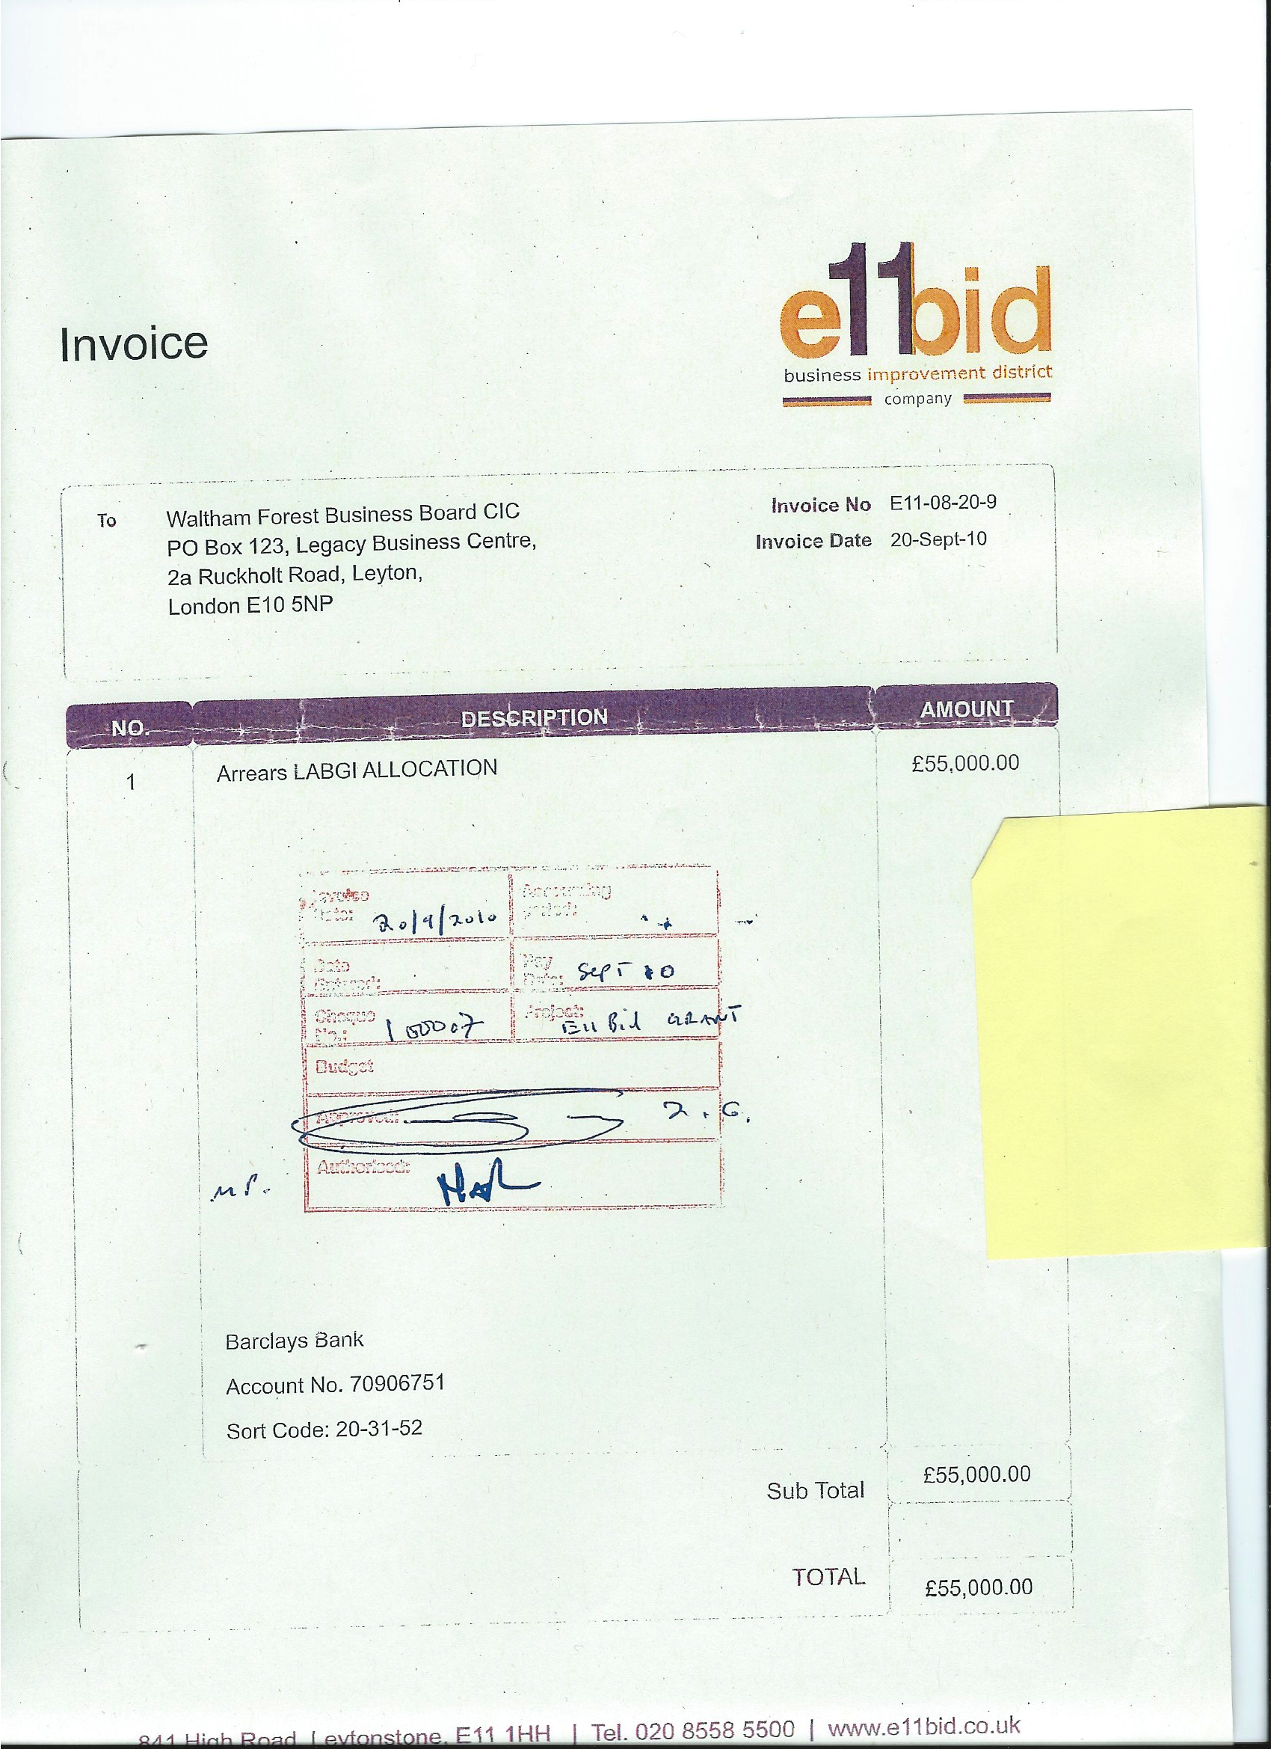

Appendix Two

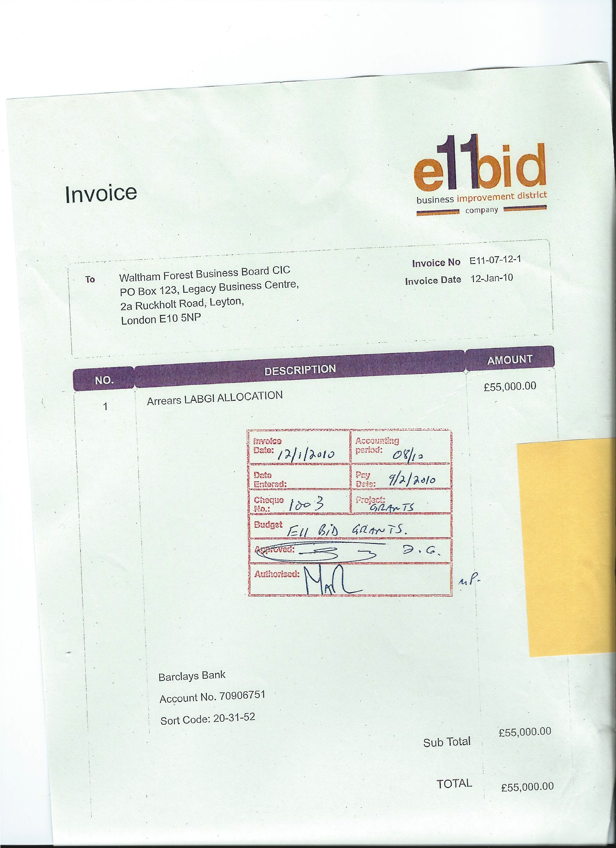

Appendix Three

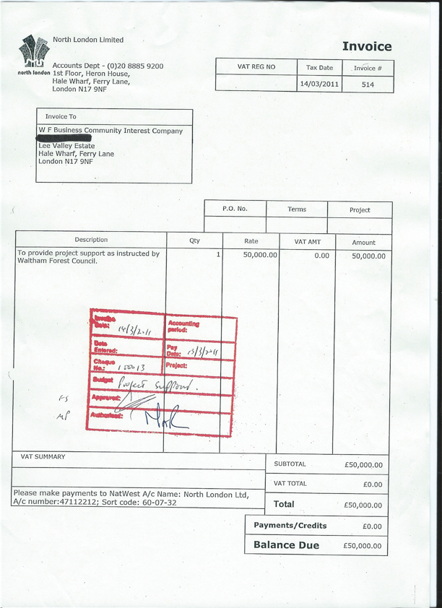

LBWF Cabinet paper, 8 December 2009; FIA deposition 20 March 2014.
Ibid.
FIA deposition, 20 March 2014.
LBWF Cabinet paper, 8 December 2009. p.2: ‘The Waltham Forest Business Board will manage the spend of the grant themselves…The Authority will enter into contract with the…Board for the administration of funds’.
Contract, Annexure C.
Letter Mustafa–Tiratsoo, 23 January 2014.
FIA deposition, 14 October 2014.
FIA deposition 24 March 2014.
FIA deposition, 27 August 2014.
FIA deposition, 27 August 2014.
FIA deposition, 5 December 2013.
FIA deposition 24 March 2014. However, it should be noted that, in answer to an earlier FIA request, LBWF stated that the dates of these two invoices were 15 January 2010 and 22 June 2010 (FIA deposition, 11 December 2013).
http://www.e11bid.co.uk/docs/AGM%202011%20Report.pdf.
See, for example, e-mails dated 23 June 2010, 26 August 2010, and 28 and 29 March 2011.
FIA deposition, 6 January, 2014
FIA deposition, 28 February 2014
Barnes Roffe LLP to ‘The Director’, 3 August 2011.
Barnes Roffe LLP to ‘The Director’, 5 December 2012.
FIA deposition, 12 November 2014.
FIA deposition, 18 March 2014
FIA depositions, 19 June 2014 and 20 November 2014.
FIA deposition, 24 October 2014.
FIA deposition, 29 October 2014.
E11 BID Co. AGM, 30 March 2011.
E11 BID Co. Board minutes, 17 May 2011 and 31 May 2012.
E11 BID Co. Board minutes, 22 November 2012.
E-mail, 6 November 2014.
Contract, 34.1.
FIA depositions, 27 October 2014 and 10 November 2014.
E-mail, 5 November 2014.
E-mails, 5 November 2014 and 20 January 2015.
E-mail, 5 November 2014.
Contract 32.14.
Ibid.
Waltham Forest Guardian, 10 April 2014 and 18 September 2014.

